AN EFFICIENT NOVEL APPROACH FOR PREDICTING STARTUP COMPANY SUCCESS RATES USING ADVANCED MACHINE LEARNING PARADIGMS
Design and Implementation
Department of Computer Science and Engineering, [COLLEGE NAME]
Batch C10 (CSE-C) · Academic year [ACADEMIC YEAR]
Table 1: Project team
S.No. | Student name | Roll number
1 | Orchu Shirisha | 23K91A05H6
2 | Mudavath Raghavendar | 23K91A05G1
3 | Majgi Vaishnavi | 23K91A05E0
4 | Polishetty Poojitha | 23K91A05J4

Project guide: P Prasanna
Chapter and section numbers quoted in the text (for example Chapter 8 or Section 6.2) refer to the full project report, 17.Final Document. Figures and tables in this document are numbered from 1.

1. DESIGN
This chapter describes how VenturePulse is organised: its design goals, architecture, data flow, main classes, stored data, core algorithm, modules and user interface. Every diagram was drawn from the real code (app/, scripts/ and frontend/src/) and reads the way the program runs.

1.1 Design Goals
• One fitted preprocessor, one model, one set of training vectors. They are created together and stored together, so training and prediction cannot disagree.
• A prediction plus its evidence. Every result carries the probability of both outcomes, the features that drove the model and the comparable historical startups, so that the number is never shown alone.
• Leakage-safe retrieval. The comparable startups are searched among training rows only, the company name is masked in descriptions, and the evaluation fits every transformation on the training part of each split.
• Runs on a student laptop. CPU only, open-source packages, no external prediction service and no API key; everything stays on localhost.
• Measured, not promised. The performance and insights screens read the numbers from the stored evaluation files and the loaded training table, so the screens cannot show a figure that was not computed.

1.2 System Architecture
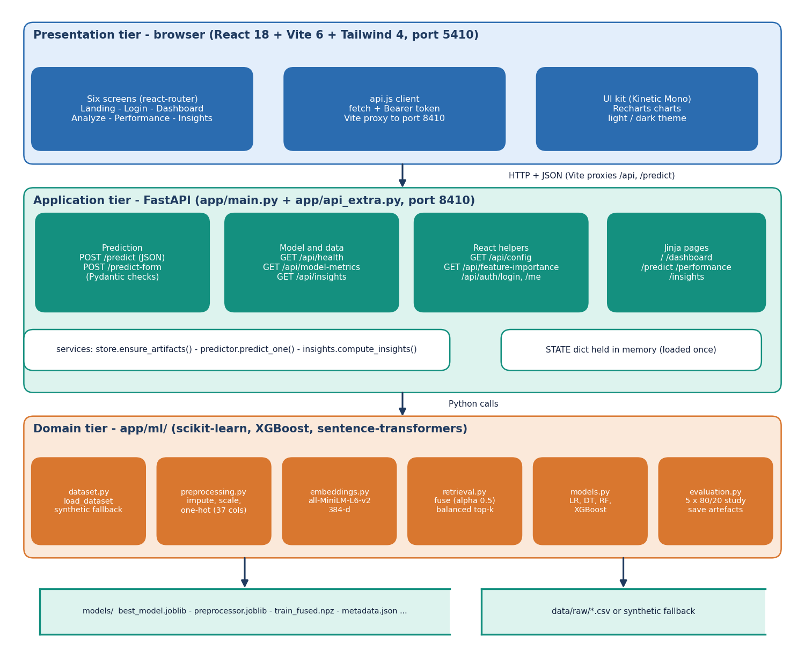
Figure 1: System architecture of VenturePulse: presentation, application and domain tiers over two stores.
There are three tiers over two stores. The presentation tier is a React 18 application (Vite 6, Tailwind CSS 4, Recharts, port 5410) with six screens: the landing page, the sign-in and the four application screens under /app. The Vite server proxies /api and /predict to the backend, so the browser talks to one origin. The application tier is a FastAPI service on port 8410: app/main.py (209 lines) holds the original routes and the validation model, app/api_extra.py (160 lines) adds the read-only routes and the demo sign-in for the React screens, and three services keep the routes thin. The domain tier in app/ml/ has six modules (dataset, preprocessing, embeddings, retrieval, models and evaluation). The two stores are the models/ folder and the startup CSV or synthetic fallback; no SQL database is used. The original Jinja pages (/dashboard, /predict, /performance, /insights) are served by the same backend and use the same services, so the two front ends show the same numbers.

1.3 High-Level Workflow
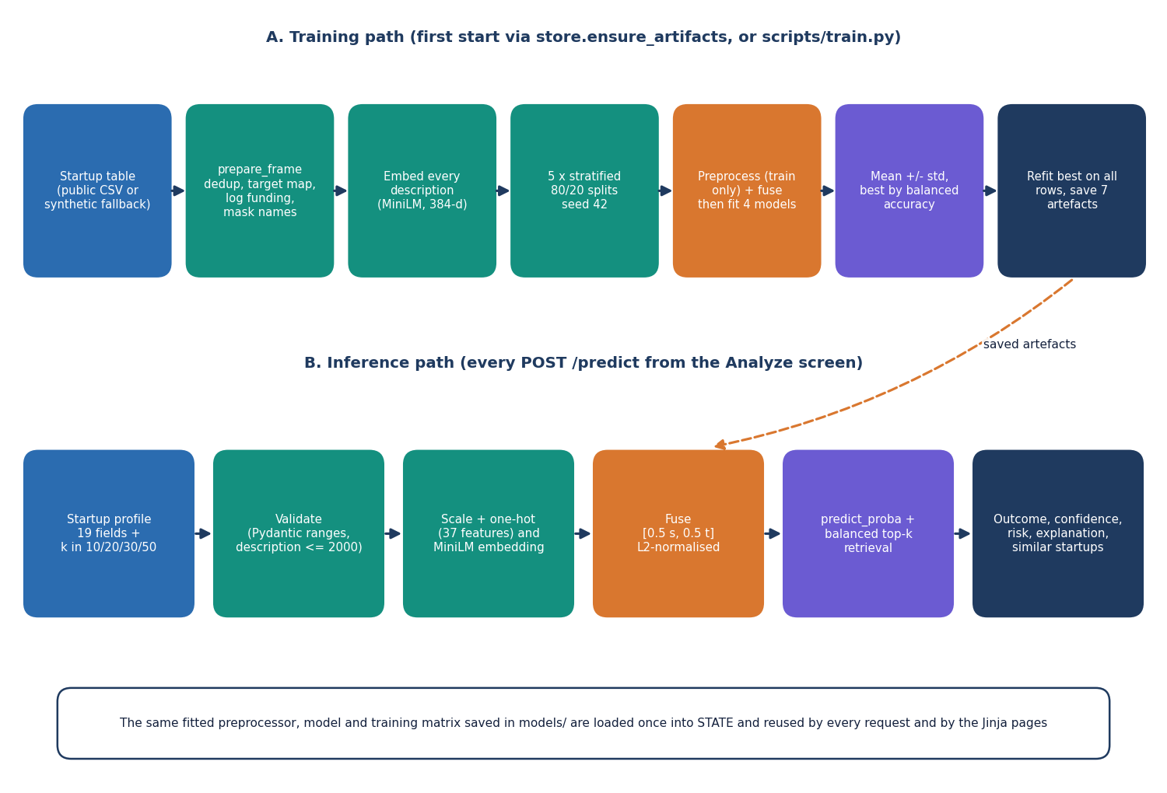
Figure 2: High-level workflow: the training path (first start or scripts/train.py) and the inference path (every POST /predict).
The offline path prepares the data, compares four classifiers over five repeated splits, selects the best by balanced accuracy and stores the artefacts; it runs automatically on the first start if any artefact is missing. The online path applies the stored objects to one submitted startup. Both paths use the same fusion function, so a submitted startup is represented exactly like a training row. On the development machine one prediction takes a median of 148 ms at k = 10 and 198 ms at k = 50 (measured through HTTP on 127.0.0.1).

1.4 Data Flow Diagrams
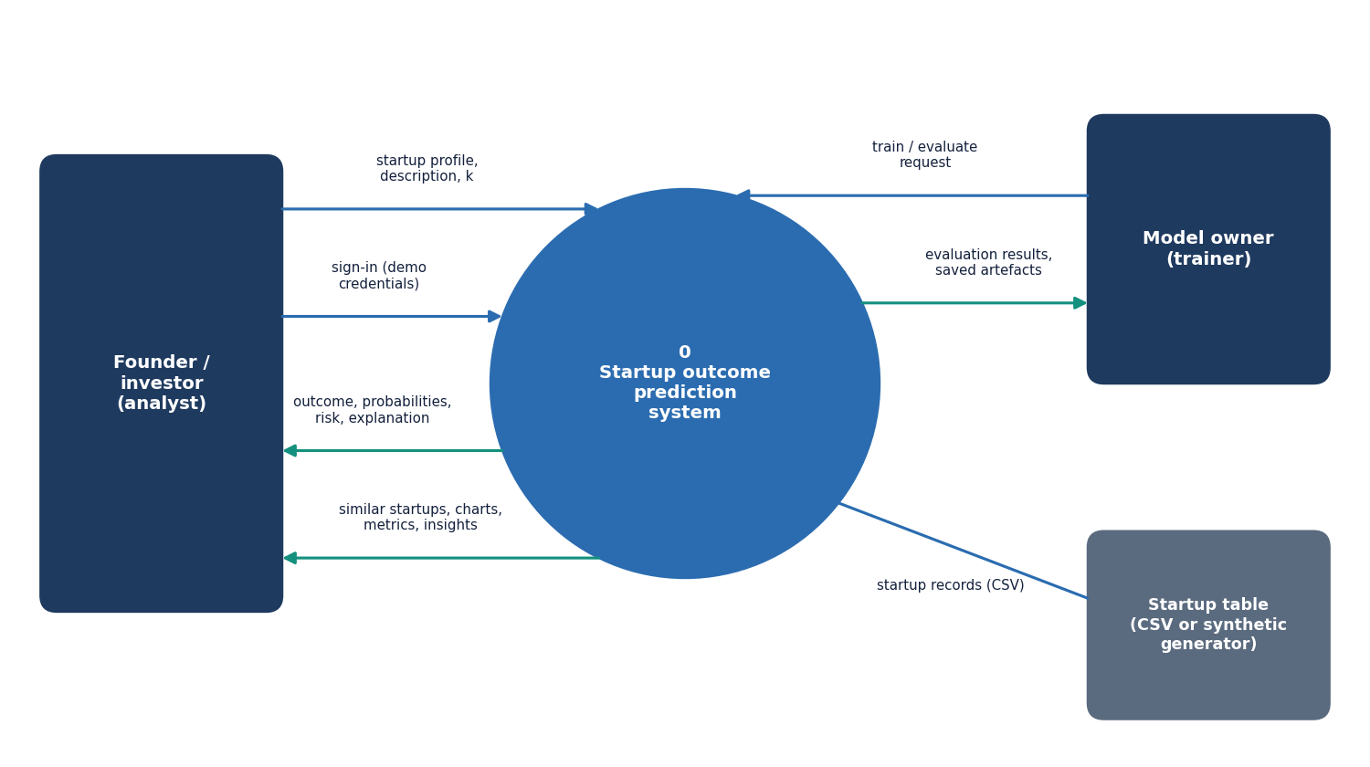
Figure 3: Level 0 data flow diagram: the system as one process with three external entities.
Level 0. The founder or investor sends credentials and a startup profile and receives an outcome estimate with evidence; the model owner sends a train and evaluate request and receives the evaluation results and the saved artefacts; the startup table supplies the records.
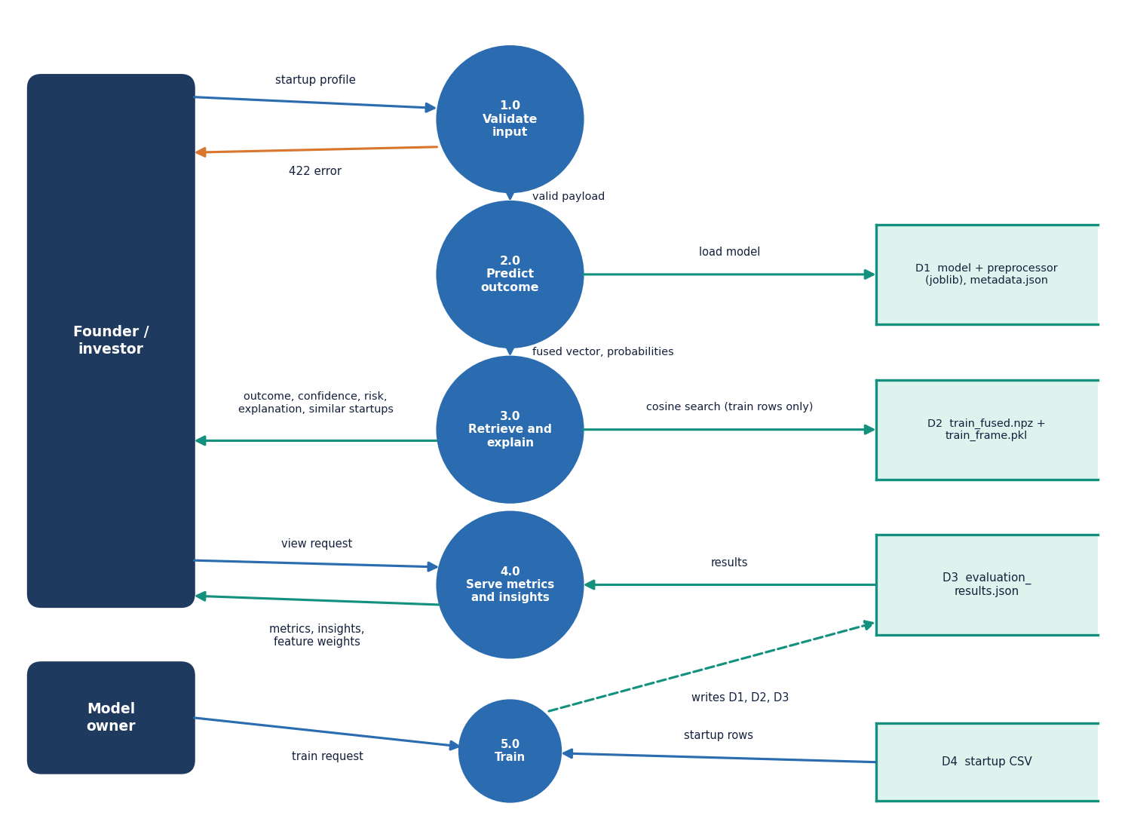
Figure 4: Level 1 data flow diagram: five processes and four data stores.
Level 1. Five processes: 1.0 Validate input, 2.0 Predict outcome, 3.0 Retrieve and explain, 4.0 Serve metrics and insights and 5.0 Train. The stores are D1 (model, preprocessor and metadata), D2 (fused training matrix and training table), D3 (evaluation results) and D4 (the startup CSV). Process 5.0 is the only one that writes D1, D2 and D3; the others only read them.
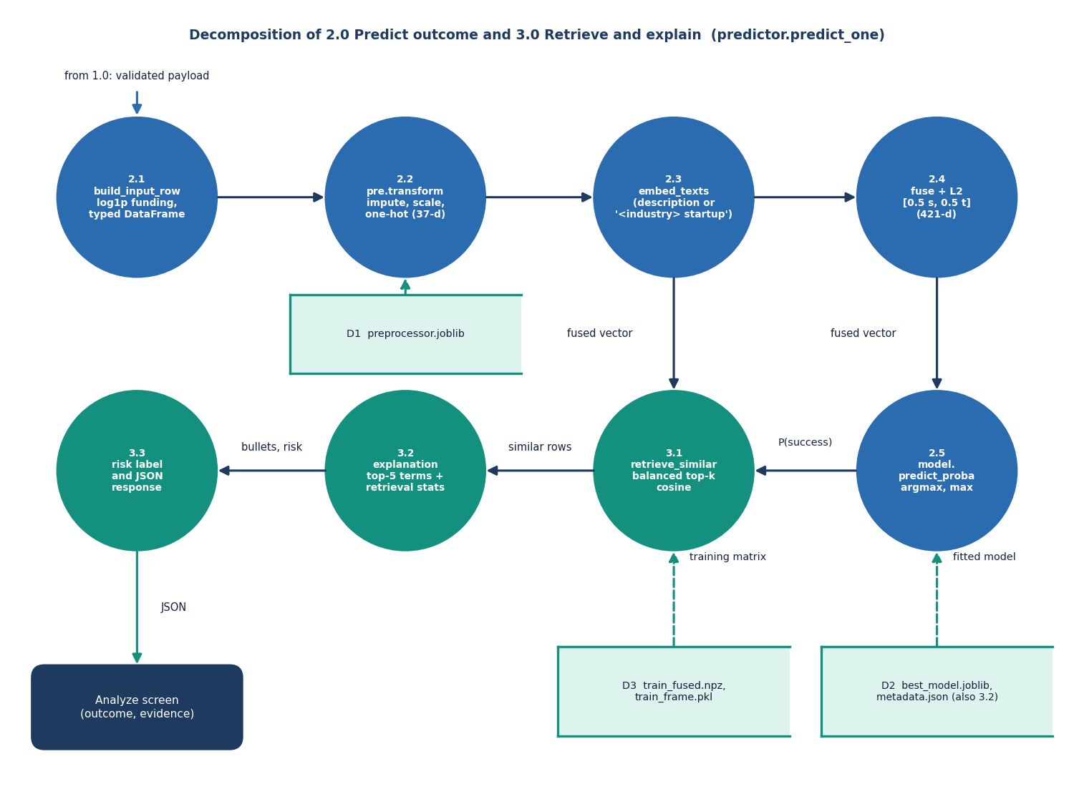
Figure 5: Level 2 data flow diagram: the steps inside 2.0 Predict outcome and 3.0 Retrieve and explain (predict_one).
Level 2. Process 2.0 follows predict_one through five steps: build the input row (2.1), transform the structured values (2.2), embed the description (2.3), fuse (2.4) and classify (2.5). Process 3.0 has three: retrieve the comparable startups (3.1), build the explanation (3.2) and add the risk label and the JSON response (3.3). Steps 2.5 and 3.1 both use the fused vector and are independent of each other.

1.5 UML Diagrams
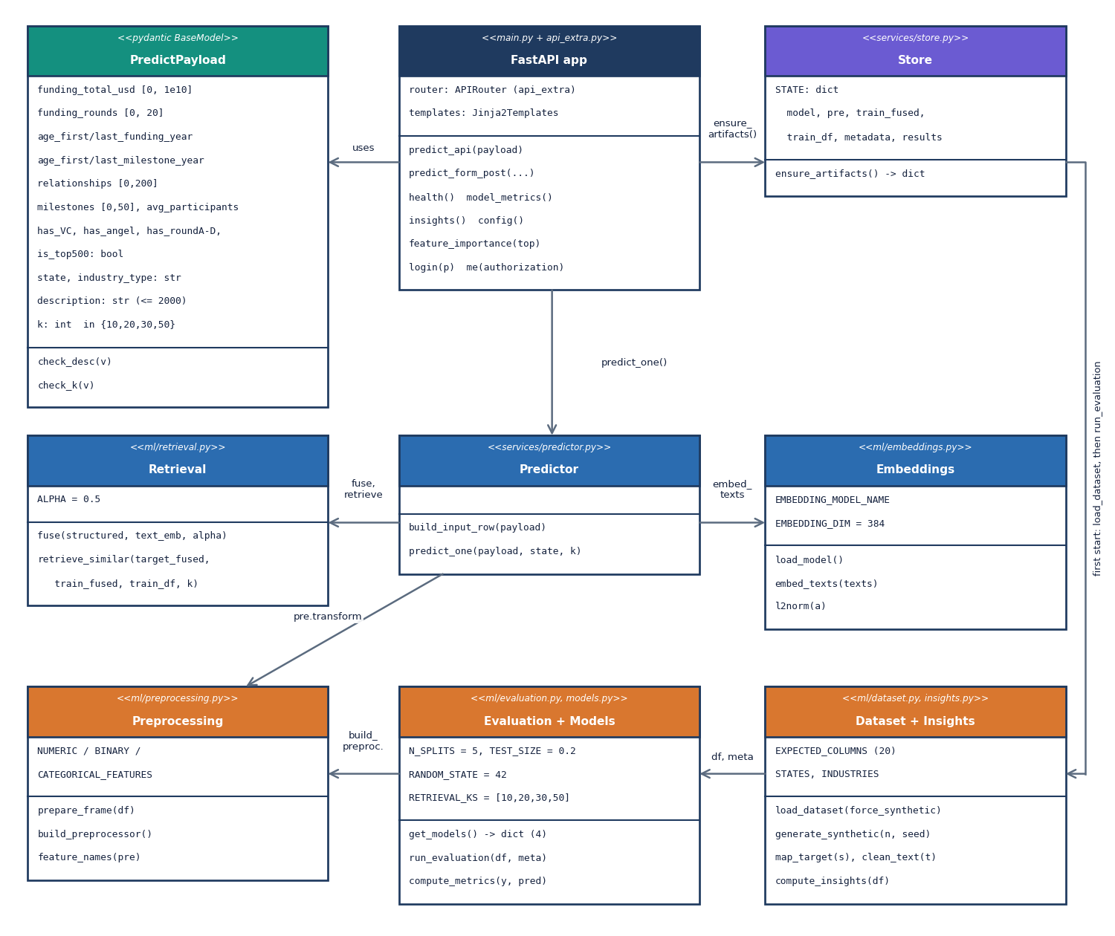
Figure 6: UML class diagram of the main classes and modules.
Class diagram. PredictPayload validates the input. The Store module owns the loaded artefacts in STATE; Predictor converts a payload into a result using Preprocessing, Embeddings and Retrieval and the best model; Evaluation + Models is the only code that fits and saves models; Dataset + Insights loads or generates the table and summarises it. The model objects themselves are standard scikit-learn and XGBoost classes.
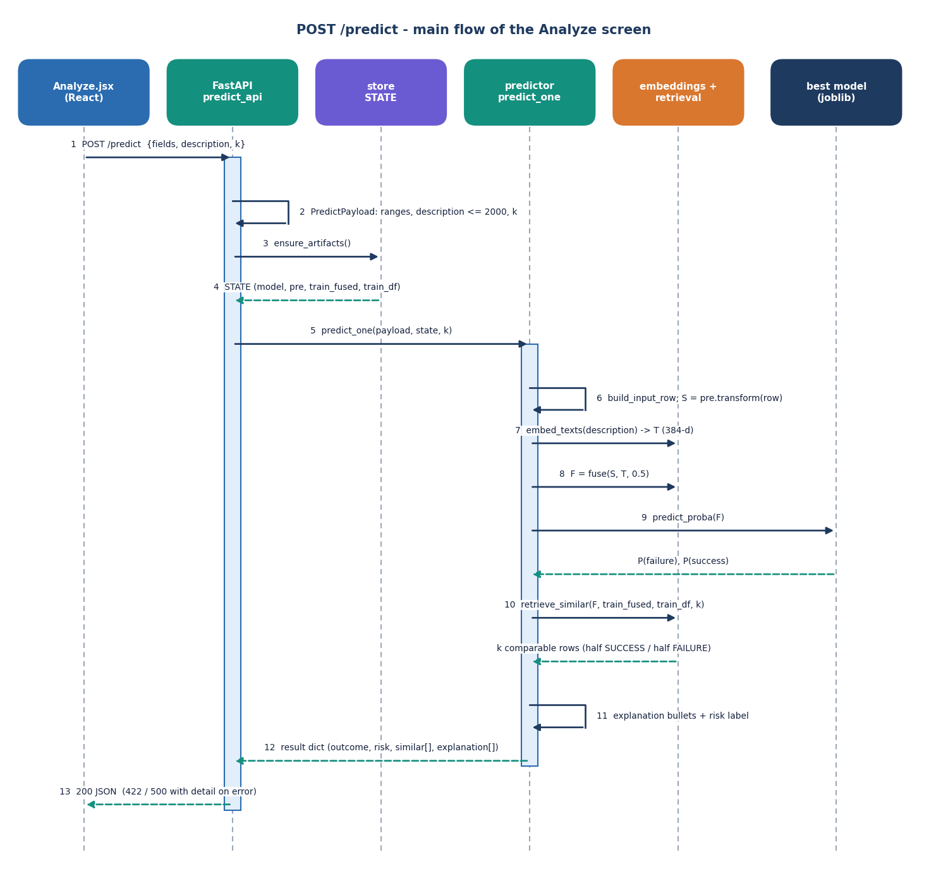
Figure 7: Sequence diagram of one POST /predict request, from the Analyze screen to the model and back.
Sequence: one prediction. The page posts the payload, FastAPI validates it, the predictor builds the row, transforms, embeds, fuses and classifies, retrieval picks the comparable startups, and the explanation is built from the model weights. The measured end-to-end time is a median of 198 ms at k = 50 (95th percentile 583 ms, maximum 716 ms over 30 requests).
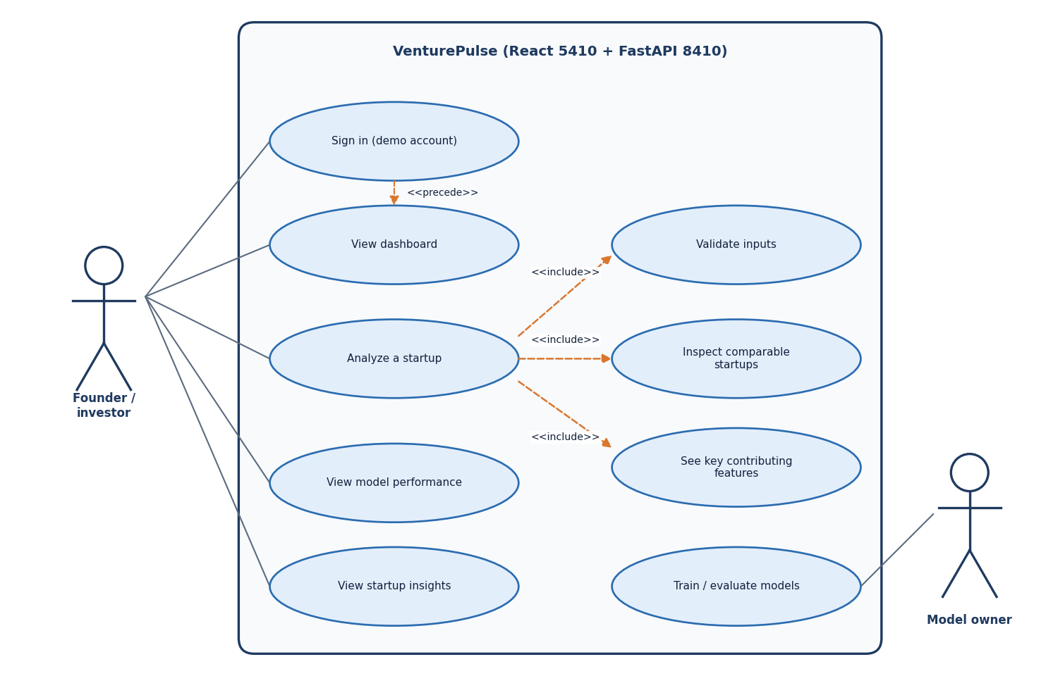
Figure 8: Use case diagram: two actors and eight use cases of VenturePulse.
Use cases. After signing in, the founder or investor views the dashboard and analyses a startup (which includes validation, the comparable startups and the key features), and opens the model performance and insights screens. The model owner trains and evaluates the models from the scripts. The product has one demo account and no role model.

1.6 Data Design
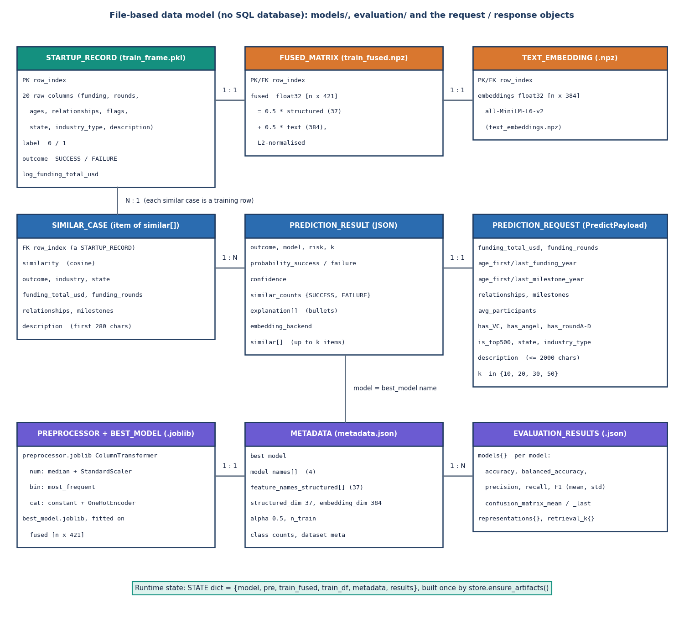
Figure 9: Entity-relationship diagram of the data model; the product has no SQL database.
The product has no SQL database because it keeps no per-user records; the diagram shows the file-based data model. The startup table, the fused matrix and the embeddings are aligned row by row; the preprocessor and the model are fitted from them; the metadata and evaluation files describe them; requests and results are transient.
Table 2: Stored artefacts
Artefact | Location | Content
Historical table | models/train_frame.pkl | 1,400 rows x 23 columns (inputs, description, status, label, outcome, log funding)
Fused training vectors | models/train_fused.npz | 1,400 x 421 float32 (37 structured + 384 text values), unit length
Text embeddings | models/text_embeddings.npz | 1,400 x 384 MiniLM vectors
Preprocessor | models/preprocessor.joblib | ColumnTransformer: median imputer + scaler, most-frequent imputer, one-hot encoder
Best model | models/best_model.joblib | Logistic Regression (selected by balanced accuracy)
Metadata | models/metadata.json | best model, feature names, alpha, embedding backend, class counts, dataset source and the synthetic-fallback flag
Evaluation results | evaluation/evaluation_results.json | mean and standard deviation of five metrics for each model, representation study, retrieval-k study
Real-data results | evaluation/real_results.json, extra_results.json | Studies on the 922-row public table (Chapter 8)

The shipped artefacts were produced from the synthetic fallback table (data/raw/SYNTHETIC_FALLBACK.txt and the synthetic_fallback flag in the metadata say so). If a CSV of the public table is placed in data/raw/ and the artefacts are deleted, the next start retrains on it without a code change. The description column of the historical table is the only free text; company names matching a simple pattern are replaced by "this company" and the text is cut at 2,000 characters.

1.7 Algorithm Design
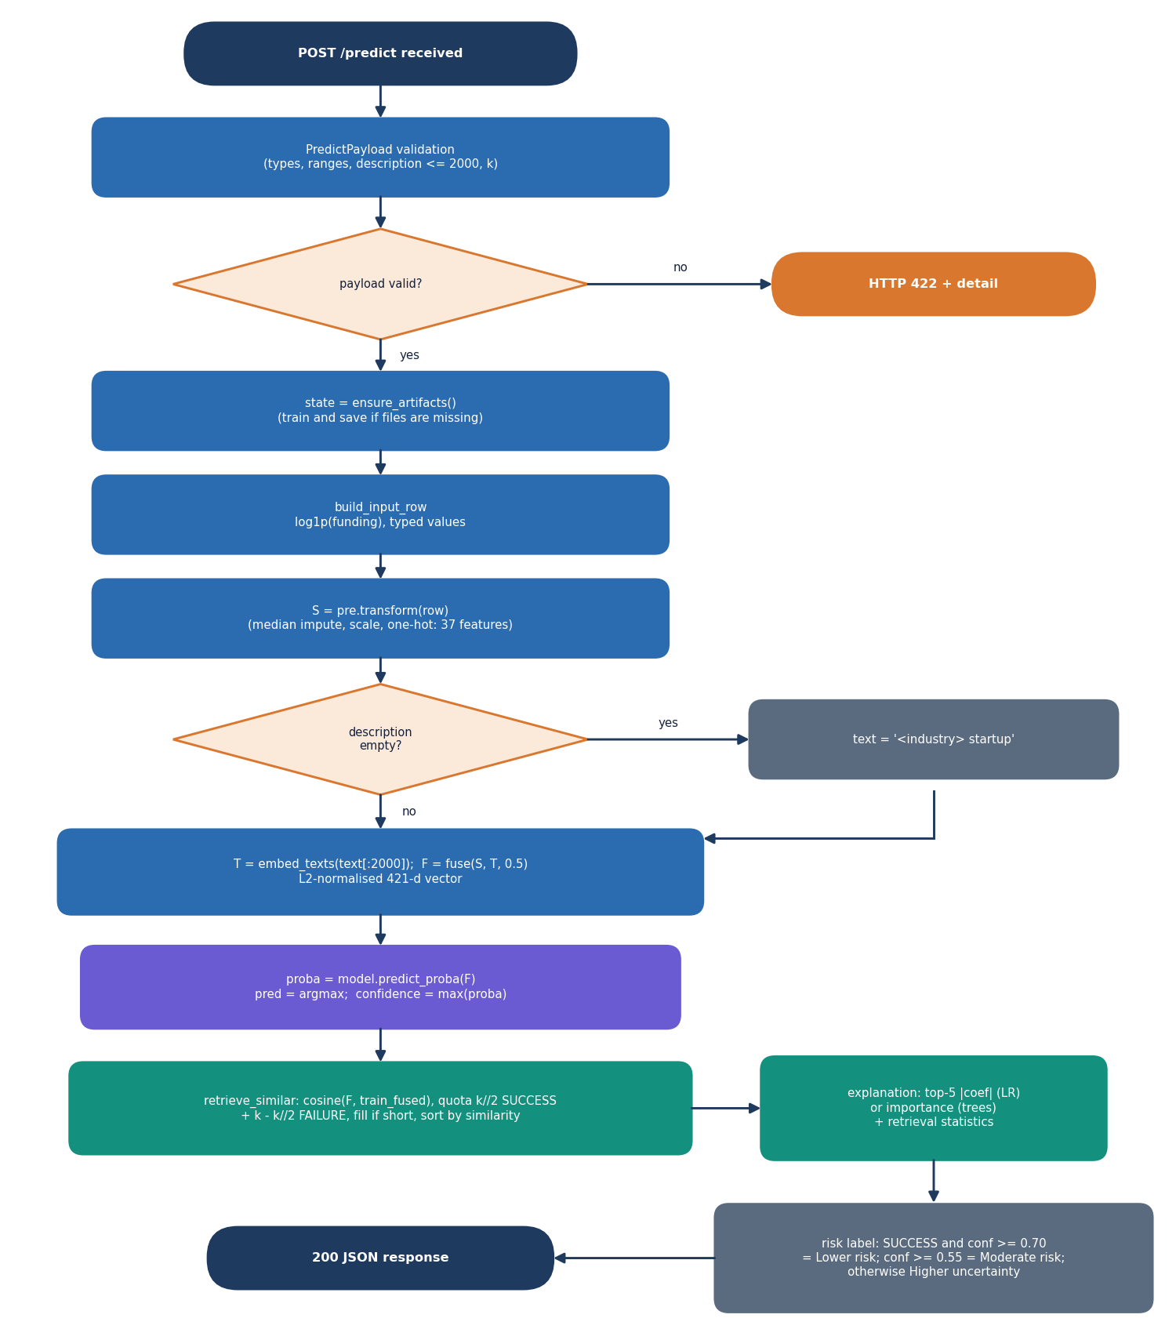
Figure 10: Flowchart of the core algorithm: validation, fusion, classification, balanced retrieval and the risk label.
Fused representation. The structured vector s is the output of the preprocessor (nine numeric fields and the log of funding scaled, seven flags, and ten state and ten industry indicator columns, 37 values). The text vector t is the 384-value MiniLM embedding of the description. Both are scaled to unit length, so each block has the same norm; the fused vector is [alpha s, (1 - alpha) t] with alpha = 0.5, scaled to unit length again, which makes cosine similarity equal to a dot product.
Classification. The model compared in the application are Logistic Regression, Decision Tree, Random Forest and XGBoost, all with class balancing. The best one by mean balanced accuracy serves the predictions; the outcome is the class with the larger probability, which for two classes means a threshold of 0.5 on P(success).
Balanced retrieval. The training vectors are sorted by cosine similarity to the fused vector of the submitted startup. The first k//2 successes and k - k//2 failures are kept, so the evidence shown is half and half even when the table is imbalanced; if one class has too few rows the quota is filled from the remaining nearest rows. The displayed list is sorted by similarity. Search uses training rows only.
Explanation and risk label. For a linear model the five features with the largest absolute coefficients are listed with the scaled value and the sign of coefficient x value (supports SUCCESS or supports FAILURE); for a tree model the five largest importances are listed. Two lines summarise the retrieval (the class counts and the top similarity, and the mean similarity to each class). The risk label is "Lower risk" if the outcome is SUCCESS with confidence at least 0.70, "Moderate risk" if the confidence is at least 0.55, and "Higher uncertainty" otherwise.
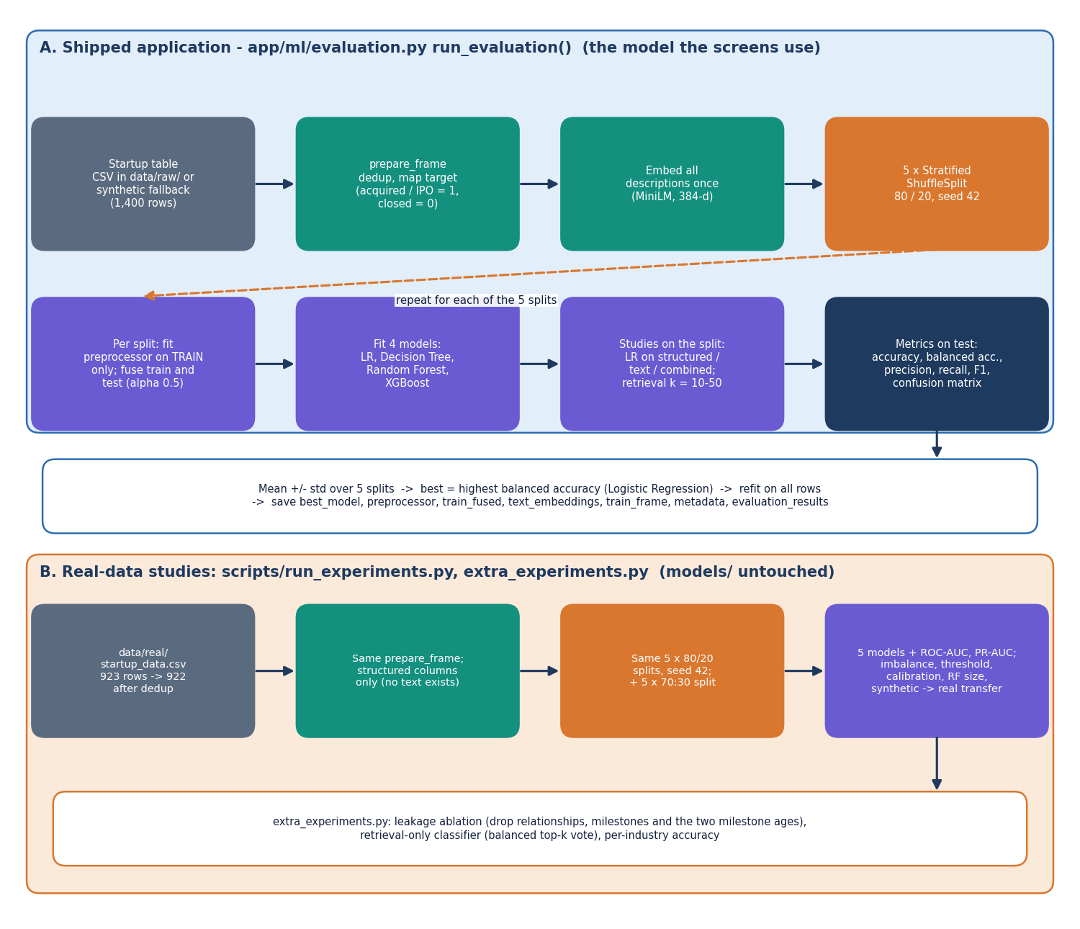
Figure 11: Evaluation protocol: (A) the study that selects the shipped model and (B) the studies on the real public table.
Evaluation. The protocol of the figure is applied to every model and every representation, and the real-data studies of Chapter 8 repeat it on the public table with extra models, imbalance strategies and a threshold sweep.

1.8 Module Design
Table 3: Modules and their responsibilities
Module | Lines | Main contents
app/main.py | 209 | FastAPI app, PredictPayload with range and k validators, /api/health, /api/model-metrics, /api/insights, POST /predict, the Jinja pages and /predict-form
app/api_extra.py | 160 | /api/config, /api/feature-importance, /api/auth/login, /api/auth/me, token functions, field ranges
app/services/store.py | 41 | ensure_artifacts: load artefacts into STATE; train first if a file is missing
app/services/predictor.py | 117 | build_input_row, predict_one: embedding, fusion, classification, retrieval, explanation, risk label
app/services/insights.py | 31 | compute_insights: counts, success rate by industry and state, median funding, correlations
app/ml/dataset.py | 237 | Local CSV / Kaggle loader, generate_synthetic, target mapping, clean_text, load_dataset
app/ml/preprocessing.py | 75 | prepare_frame (dedup, target, coercion, log funding), build_preprocessor, feature_names
app/ml/embeddings.py | 70 | MiniLM loader and embed_texts, deterministic hashing fallback, l2norm
app/ml/retrieval.py | 55 | fuse, retrieve_similar (balanced cosine top-k)
app/ml/models.py | 27 | get_models: four classifiers with their hyper-parameters
app/ml/evaluation.py | 273 | run_evaluation: 5 x 80/20 study, representation and retrieval-k studies, refit, charts, JSON
app/templates/ | 143 | Six Jinja templates (base, dashboard, predict, result, performance, insights)
frontend/src/ | 3,045 | Pages (923 lines), components (UI kit, charts), API client, auth, theme and activity log
scripts/ | 612 | run_experiments.py, extra_experiments.py, edge_tests.py, smoke_test.py, measure_latency.py, train.py

The services cache everything in STATE, so the artefacts are read from disk once per process. Server state in the React application is handled by a small useApi hook with an error-description helper that turns a failed request into a message and a hint (for example, a 422 asks the user to correct the highlighted values).

1.9 User Interface Design
The interface follows a dark, monospace-accented layout with a light theme that can be switched and is remembered in the browser. The application screens share one shell: a sidebar with the four screens and their keyboard shortcuts, a top bar with a screen-jump search box (press /) and the theme toggle, and a card showing the serving model and the number of historical startups. Colour is never the only signal: each outcome has a label and each probability bar has its value written next to it; every form field has a label and an error message.
Table 4: Screens
Route | Screen | Main elements
/ | Landing | Hero, technology strip, how it works, feature overview, link to the demo sign-in
/login | Sign in | Email and password, a button that fills the demo account, error message on a wrong password
/app | Dashboard | Four statistic cards, best validated model, class distribution donut, model comparison bars, how it works, pipeline configuration
/app/analyze | Analyze a startup | Cards for funding and traction, company profile (industry, state, k), investor signals, description (2,000 characters); result with outcome, probability bars, explanation, evidence donut, comparable startups table, submitted inputs
/app/performance | Model performance | Comparison table (mean and standard deviation), balanced accuracy and F1 bars, precision against recall, confusion matrix, retrieval-size and representation studies, feature importance
/app/insights | Startup insights | Success rate by industry and state, industry table, median funding by outcome, correlation of five fields with SUCCESS

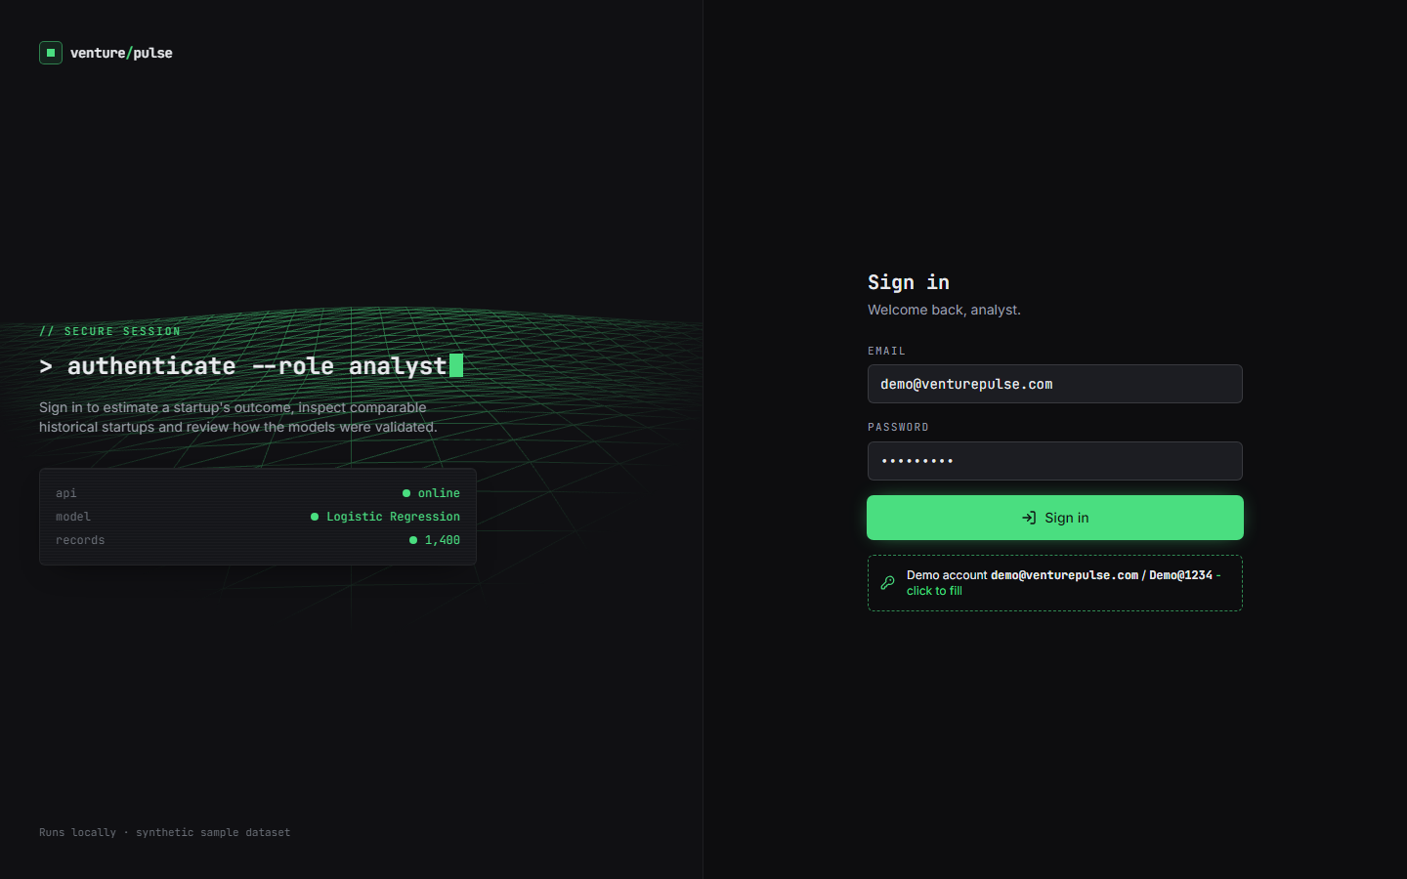  Figure 12: Sign-in screen with the demo account. | 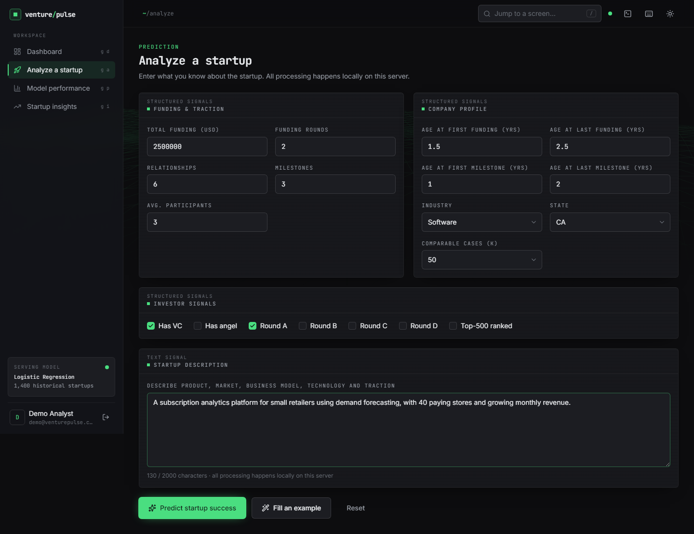  Figure 13: Analyze screen with a submitted example filled in.

The original server-rendered pages show the same four views without a sign-in and are kept so that the backend remains usable on its own. Their prediction form insists on a description (status 400 if it is empty), whereas the JSON route POST /predict accepts an empty description and embeds the industry name instead. The results of every screen are shown and discussed in Chapter 8.

1.10 Design Decisions and Their Consequences
Table 5: Design decisions
Decision | Reason | Consequence
Fuse structured and text vectors by concatenation with weight 0.5 | Gives one vector for classification and retrieval; no extra training | Both blocks count equally whatever their usefulness; alpha was fixed, not tuned
Balanced retrieval quota | Shows evidence for both outcomes even when the table is imbalanced | The displayed counts are always about k/2 each, so they do not show the real class ratio
Logistic Regression as served model | Highest balanced accuracy on the shipped (synthetic) table; transparent coefficients | On the real table Random Forest and XGBoost score higher (Chapter 8); the served model was chosen on synthetic data
Search training rows only | No test row can retrieve itself | A new startup cannot be compared with startups added after training until the artefacts are rebuilt
Artefacts as files, no database | Simple local deployment; nothing to administer | No audit trail, no per-user history; one process holds the state
Deterministic explanation | Same input gives the same text; no sampling | Coefficient-based reasons describe the model, not causes in the real world
Synthetic fallback when the public CSV is absent | The application always starts | Shipped statistics come from 1,400 generated rows and must not be read as real performance
Hash-based embedding fallback | The application still runs if the transformer cannot be loaded | Retrieval quality would drop; the backend name is returned in every result
Demo token in a header | Lets the React screens demonstrate a sign-in | Not a security boundary: one shared account, and the prediction route itself needs no token

The design favours a system that can be run, inspected and measured over a large one. The cost shows in the missing founder and team-experience inputs, the single demo account and the fixed fusion weight; these are listed with the other limits in Chapters 9 and 10.

2. IMPLEMENTATION

2.1 Application architecture
Backend. app/main.py creates the FastAPI application, mounts the static folder, includes the router of app/api_extra.py and defines the routes. Each route calls ensure_artifacts(), which fills the module-level STATE dictionary once per process: it loads best_model.joblib, preprocessor.joblib, train_fused.npz, train_frame.pkl, metadata.json and the evaluation results; if any of the first five files is missing it loads the dataset, prepares it and runs run_evaluation first, which is why the first start takes several minutes. predict_one is a plain function, so the same code is used by the JSON route and by the form route of the original pages.
Frontend. The React application is a set of lazily loaded pages (Landing, Login, Dashboard, Analyze, Performance, Insights) under react-router. A Guard component redirects an unauthenticated visitor from /app to /login. The sign-in token is stored in the browser's local storage (vp_token) and an axios interceptor adds it as a bearer header. Pages fetch their data with a small useApi hook; charts use Recharts; the layout is a Tailwind CSS 4 design with light and dark tokens; an activity log records every API call with its status and time. The production build splits vendor code into separate chunks (React, charts, motion, three.js for the background grid).
Size. The backend is 1,351 lines of Python, the original templates 143 lines, the React source 3,045 lines, the tests 78 lines and the experiment and test scripts 612 lines (measured with wc -l).

2.2 API design
Table 6: Endpoints
Method and path | Request | Response
GET /api/health | none | status, app, records (training rows), best_model; 500 with detail on failure
GET /api/model-metrics | none | Evaluation JSON: models (mean and std of accuracy, balanced_accuracy, precision, recall, f1, confusion matrix), best_model, representations, retrieval_k, metadata
GET /api/insights | none | total, success, failure, success_rate, industries[], states[], median funding by outcome, correlations
POST /predict | JSON payload (below) | outcome, probability_success, probability_failure, confidence, model, risk, similar[], similar_counts, explanation[], embedding_backend, k; 422 on invalid input, 500 on error
GET /api/config | none | States, industries, allowed k values, field ranges and defaults, max_description, best model, class counts, alpha, embedding backend, dataset note, demo email
GET /api/feature-importance?top=N | N (default 15) | model, kind (abs_coefficient or importance), features[] with value and, for linear models, the signed coefficient
POST /api/auth/login | email, password | token, user; 401 with detail if wrong
GET /api/auth/me | Authorization: Bearer <token> | name, email; 401 if the token is missing, altered or expired
GET /, /dashboard, /predict, /performance, /insights | none | Original server-rendered pages
POST /predict-form | Form fields | Result page; 400 with a message if the description is empty or too long, or the values are invalid

The payload of POST /predict has 20 fields, all optional with defaults: the nine numeric fields (funding_total_usd, funding_rounds, age_first_funding_year, age_last_funding_year, age_first_milestone_year, age_last_milestone_year, relationships, milestones, avg_participants), the seven flags (has_VC, has_angel, has_roundA, has_roundB, has_roundC, has_roundD, is_top500), state, industry_type, description and k.
POST /predict
{"funding_total_usd": 2500000, "funding_rounds": 2, "relationships": 6, "milestones": 3,
"has_VC": true, "has_roundA": true, "state": "CA", "industry_type": "Software",
"description": "A subscription analytics platform for small retailers ...", "k": 50}

200 OK
{"outcome": "SUCCESS", "probability_success": 0.83, "probability_failure": 0.17, "confidence": 0.83,
"model": "Logistic Regression", "risk": "Lower risk",
"similar_counts": {"SUCCESS": 25, "FAILURE": 25}, "k": 50,
"similar": [{"similarity": 0.58, "outcome": "SUCCESS", "industry": "Software", "state": "CO", ...}, ...],
"explanation": ["has_roundC: value 0.00 (scaled), weight 2.495 - supports FAILURE", ..., "Retrieved 50 comparable historical startups ..."],
"embedding_backend": "sentence-transformers"}

Measured on 127.0.0.1 with the model loaded (scripts/measure_latency.py): GET /api/health median 3.0 ms, GET /api/model-metrics 3.5 ms, GET /api/insights 14.5 ms, POST /predict 147.8 ms at k = 10 and 198.5 ms at k = 50.

2.3 Security and error handling
• Input validation. The Pydantic model rejects values outside fixed ranges: funding 0 to 1e10, rounds 0 to 20, ages 0 to 30, relationships 0 to 200, milestones 0 to 50, average participants 0 to 50; non-numeric values and a description longer than 2,000 characters are rejected; k must be one of 10, 20, 30 or 50. The response is status 422 with the field names. Unknown industries or states are accepted and handled by the one-hot encoder (unknown categories become all zeros).
• Form route. The original form refuses an empty description (400), clamps negative numbers to zero and replaces an invalid k with the default.
• Failures. Route functions catch exceptions, log them and return status 500 with a detail string; the React page turns a failed request into a message with a hint (for example, "Start the app with run.bat" when the server cannot be reached). The embedding step falls back to the hashing embedding if the transformer cannot be loaded.
• Demo sign-in. The credentials come from the environment or from .env (DEMO_EMAIL, DEMO_PASSWORD, DEMO_SECRET); the defaults are the demo account. The email and the password are compared with hmac.compare_digest. The token is a URL-safe base64 string of email|expiry|signature, where the signature is an HMAC-SHA256 of the email and the expiry; the lifetime is 12 hours and a changed or expired token is rejected with 401.
• What is not protected. The sign-in is for the React screens only: POST /predict and the original pages need no token, there is one shared account, no rate limit, no HTTPS and no audit log. Detailed exception messages are returned to the client. The application is meant to run on localhost and must not be exposed to a network as it is. No security audit or penetration test was carried out.
The 29 API edge cases of scripts/edge_tests.py (Chapter 7) check the ranges, the k whitelist, the description limit, empty and extreme values, the form route, every GET route and the token cases; all 29 pass.

2.4 Installation and execution

2.4.1 One-click start (Windows)
Install Python 3.10 or newer (3.11.9 was used) and Node.js 18 or newer, open the 8.ProjectCode folder and double-click run.bat. The script (1) checks Python and Node, (2) creates .venv, or rebuilds it if it was copied from another machine and is broken, (3) installs requirements.txt (FastAPI 0.115.6, scikit-learn 1.5.2, pandas 2.2.3, XGBoost 2.1.3, sentence-transformers 3.3.1, torch 2.5.1 and others), (4) runs npm install in frontend/ on the first run, and (5) starts the backend in a second window on port 8410, opens the browser at http://localhost:5410 and runs the Vite server on port 5410. The first start downloads the embedding model (about 90 MB) and trains the artefacts if they are missing; later starts take seconds. The ports are set in .env (BACKEND_PORT, FRONTEND_PORT).

2.4.2 By hand
python -m venv .venv
.venv\Scripts\activate
pip install -r requirements.txt
python -m uvicorn app.main:app --host 127.0.0.1 --port 8410

# second terminal
cd frontend
npm install
npm run dev

Sign in with the demo account demo@venturepulse.com / Demo@1234 (the sign-in page has a button that fills it), then use the Dashboard, Analyze a startup, Model performance and Startup insights screens. To use real data, copy the public CSV into data/raw/, delete the files in models/ and restart; the artefacts are rebuilt and the metadata then records the source.

2.4.3 Checks and scripts
.venv\Scripts\python.exe -m pytest tests -q # 7 tests
.venv\Scripts\python.exe scripts\smoke_test.py # 15 checks against a running server
.venv\Scripts\python.exe scripts\edge_tests.py # 29 API edge cases
.venv\Scripts\python.exe scripts\run_experiments.py # real-data study -> evaluation/real_results.json
.venv\Scripts\python.exe scripts\extra_experiments.py # leakage ablation, retrieval-only, per industry
.venv\Scripts\python.exe scripts\measure_latency.py # latency of the API

A Docker route (run-docker.bat, Dockerfile) starts the backend and the original pages only; it was not exercised in this documentation run.

3. KEY CODE WALK-THROUGHS
This section walks through the code that matters most, quoting the repository as it was when the results of this report were measured.

3.1 Fusing the structured and text representations
fuse L2-normalises the scaled structured vector and the text embedding separately, scales them by alpha and 1 - alpha, concatenates them and normalises again, so that the dot product of two fused vectors is their cosine similarity. retrieve_similar then ranks all training rows by that similarity and fills a half-success, half-failure quota, topping up from the nearest remaining rows if one class runs short. Only training rows are searched.

def fuse(structured: np.ndarray, text_emb: np.ndarray, alpha: float = ALPHA) -> np.ndarray:
s = np.asarray(structured, dtype=np.float64)
t = np.asarray(text_emb, dtype=np.float64)
s = l2norm(s.astype(np.float32)).astype(np.float64)
t = l2norm(t.astype(np.float32)).astype(np.float64)
fused = np.hstack([alpha * s, (1.0 - alpha) * t])
# final L2 normalize so cosine similarity is well-behaved
n = np.linalg.norm(fused, axis=1, keepdims=True)
n[n == 0] = 1.0
return (fused / n).astype(np.float32)

def retrieve_similar(target_fused: np.ndarray, train_fused: np.ndarray,
train_df: pd.DataFrame, k: int = 50) -> pd.DataFrame:
sims = cosine_similarity(target_fused.reshape(1, -1), train_fused)[0]
order = np.argsort(-sims)
# balanced selection: quotas half/half where possible
k = int(max(1, min(k, len(order))))
quota_s = k // 2
quota_f = k - quota_s
labels = train_df["label"].to_numpy()
picked: list[int] = []
c_s = c_f = 0
for idx in order:
lab = int(labels[idx])
if lab == 1 and c_s < quota_s:
picked.append(int(idx)); c_s += 1
elif lab == 0 and c_f < quota_f:
picked.append(int(idx)); c_f += 1
if len(picked) >= k:
break
# fill remainder if a class ran short
if len(picked) < k:
chosen = set(picked)
for idx in order:
if int(idx) not in chosen:
picked.append(int(idx))
if len(picked) >= k:
break
# sort picked by similarity desc for display
picked = sorted(picked, key=lambda i: -sims[i])
out = train_df.iloc[picked].copy()
out["similarity"] = [float(sims[i]) for i in picked]
return out

3.2 The prediction path
predict_one builds one input row (adding the log of the funding total), transforms it with the fitted preprocessor, embeds the description (or, if it is empty, a short sentence made of the industry) and fuses both parts. The model gives P(failure) and P(success); the outcome is the larger one and the confidence is its value. The same fused vector is used for the retrieval of comparable startups.
def predict_one(payload: dict, state: dict, k: int = DEFAULT_K) -> dict:
model = state["model"]
pre = state["pre"]
train_fused = state["train_fused"]
train_df = state["train_df"]
meta = state["metadata"]
k = int(max(1, min(int(k or DEFAULT_K), len(train_df))))

inp = build_input_row(payload)
S = pre.transform(inp)
T, backend = embed_texts([inp.iloc[0]["description"] or f"{inp.iloc[0]['industry_type']} startup"])
F = fuse(S, T, ALPHA)

proba = None
if hasattr(model, "predict_proba"):
proba = model.predict_proba(F)[0]
pred = int(np.argmax(proba))
conf = float(np.max(proba))
else:
pred = int(model.predict(F)[0])
conf = 0.5
proba = np.array([1 - conf, conf]) if pred == 1 else np.array([conf, 1 - conf])

similar = retrieve_similar(F[0], train_fused, train_df, k=k)

3.3 Risk label
The risk label is a fixed rule on the predicted class and the confidence, not a separate model. It reads the confidence of the winning class only, so a FAILURE prediction with high confidence is labelled Moderate risk rather than Lower risk.
risk = "Lower risk" if (pred == 1 and conf >= 0.7) else ("Moderate risk" if conf >= 0.55 else "Higher uncertainty")

3.4 The evaluation loop
The evaluation fits the preprocessor on the training part of each of the five stratified 80/20 splits only, fuses the features, trains every model, scores it with accuracy, balanced accuracy, precision, recall and F1, repeats the comparison for the structured-only, text-only and combined views, and runs the retrieval vote for each k. The best model by mean balanced accuracy is the one the application serves.
sss = StratifiedShuffleSplit(n_splits=N_SPLITS, test_size=TEST_SIZE, random_state=RANDOM_STATE)
model_names = list(get_models().keys())
per_model: dict[str, list[dict]] = {m: [] for m in model_names}
rep_modes = ["structured_only", "text_only", "combined"]
rep_scores: dict[str, list[float]] = {r: [] for r in rep_modes}
k_scores: dict[str, list[float]] = {f"k={k}": [] for k in RETRIEVAL_KS}

last_split = None
for split_i, (tr, te) in enumerate(sss.split(np.zeros(len(df)), y_all)):
dtr, dte = df.iloc[tr].reset_index(drop=True), df.iloc[te].reset_index(drop=True)
ytr, yte = y_all[tr], y_all[te]
pre = build_preprocessor()
Str = pre.fit_transform(dtr)
Ste = pre.transform(dte)
Ttr = text_emb_all[tr]
Tte = text_emb_all[te]
Ftr = fuse(Str, Ttr, ALPHA)
Fte = fuse(Ste, Tte, ALPHA)
# standard models on combined fused representation
for name, model in get_models().items():
model.fit(Ftr, ytr)
pred = model.predict(Fte)
per_model[name].append(compute_metrics(yte, pred))

3.5 Signed demo token
The demo sign-in returns an HMAC-signed token containing the e-mail address and an expiry time. read_token decodes it, rejects an expired token and compares the signature in constant time. A token whose signature has been altered is refused (checked by the edge tests).
def _sign(email: str, exp: int, secret: str) -> str:
return hmac.new(secret.encode(), f"{email}:{exp}".encode(), hashlib.sha256).hexdigest()

def make_token(email: str, ttl: int = 12 * 3600) -> str:
exp = int(time.time()) + ttl
sig = _sign(email, exp, _creds()[2])
return base64.urlsafe_b64encode(f"{email}|{exp}|{sig}".encode()).decode()

def read_token(token: str | None) -> str | None:
try:
email, exp, sig = base64.urlsafe_b64decode((token or "").encode()).decode().split("|")
if int(exp) < time.time():
return None
if hmac.compare_digest(sig, _sign(email, int(exp), _creds()[2])) and email == _creds()[0]:
return email
except Exception:
pass
return None

3.6 The real-data experiment
The real-data script re-uses the application's own preprocessing and model definitions, so that the real numbers describe the same pipeline that is served. It loads the 923-row table, maps its columns to the application's schema, and runs the studies of Chapter 8.
def load_real() -> pd.DataFrame:
raw = pd.read_csv(REAL_CSV)
df = pd.DataFrame({
"age_first_funding_year": raw["age_first_funding_year"],
"age_last_funding_year": raw["age_last_funding_year"],
"age_first_milestone_year": raw["age_first_milestone_year"],
"age_last_milestone_year": raw["age_last_milestone_year"],
"relationships": raw["relationships"], "funding_rounds": raw["funding_rounds"],
"funding_total_usd": raw["funding_total_usd"], "milestones": raw["milestones"],
"avg_participants": raw["avg_participants"],
"has_VC": raw["has_VC"], "has_angel": raw["has_angel"], "has_roundA": raw["has_roundA"],
"has_roundB": raw["has_roundB"], "has_roundC": raw["has_roundC"], "has_roundD": raw["has_roundD"],
"is_top500": raw["is_top500"],
"state": raw["state_code"].where(raw["state_code"].isin(STATE_KEEP), "Other"),
"industry_type": raw["category_code"].map(INDUSTRY_MAP).fillna("Other"),
"description": "",
"status": raw["status"],
})
return prepare_frame(df)

def score(y, pred, proba) -> dict:
return {
"accuracy": accuracy_score(y, pred), "balanced_accuracy": balanced_accuracy_score(y, pred),
"precision": precision_score(y, pred, zero_division=0), "recall": recall_score(y, pred, zero_division=0),
"f1": f1_score(y, pred, zero_division=0), "roc_auc": roc_auc_score(y, proba),
"pr_auc": average_precision_score(y, proba),
}

4. IMPLEMENTATION DECISIONS AND THEIR REASONS
Table 7: Implementation decisions and their reasons
Decision | Reason | What was observed
Select the served model by balanced accuracy | With unequal classes, plain accuracy rewards predicting the majority; balanced accuracy averages the recall of both classes [2] | On the synthetic table Logistic Regression wins (0.749); on the real table XGBoost and Random Forest tie at 0.746
class_weight = balanced for LR, tree and forest | Cheap algorithm-level remedy for imbalance that does not alter the data [22] | On real data it did not raise ROC-AUC; it trades recall of the majority class for precision (L7)
Embed the description with all-MiniLM-L6-v2 on the CPU | 384-d sentence embeddings, small enough to run locally without a GPU or an external service [26, 25] | First request loads the model; later predictions take a median of 148 ms at k = 10
Hashing fallback embedding if the transformer cannot load | The application must still start without the model download | Reported in the response as embedding_backend; not used in the measurements
Fuse with alpha = 0.5 and normalise twice | Gives both views equal weight and turns cosine similarity into a dot product | Alpha was not tuned (not measured)
Balanced half/half retrieval quota | A plain top-k would mostly return the majority outcome | On the synthetic table k = 50 gave 0.698 balanced accuracy against 0.654 for k = 10; on real structured data k hardly matters
Search training rows only | Prevents a test startup from retrieving itself or its siblings (leakage) | Retrieval accuracy is therefore an honest out-of-sample figure
Mask the company name in the description | Prevents a language model or embedding from using a known brand [2] | Done in clean_text before embedding
Store models and data as files, keep state in memory | A local single-user teaching application needs no database | Fast start; cannot serve several users (L10)
Demo HMAC token for the React screens | Gives the interface a sign-in without user management | Tampered token rejected in the edge tests; not a security design
Pydantic ranges and a k whitelist {10, 20, 30, 50} | Reject nonsense and oversized input before it reaches the model | 29 of 29 edge cases behave as expected (422 for out-of-range values)
Separate real-data script instead of changing the shipped model | The model files were trained before the real table was found; changing them was not required to measure | Real and synthetic numbers kept apart in every table

